**LEBANESE AMERICAN UNIVERSITY**

**USAID – HIGHER EDUCATION SCHOLARSHIP PROGRAM**

**HES - Volunteering Program Verification Form**

This form is to be used to document volunteering hours. If a student volunteers for multiple organizations, a separate form must be used for each organization. **This form must be turned in by the 28th of each month, the latest.**

I certify that the scholar Nada Elhamad completed a total of 5 hours of service at InnovaThrive.

The hours were completed hours as per the below:

Hours # 0 (date) _2/12 – 6/12_ (initials of supervisor) __A.K.___

Hours # 0 (date) _9/12 – 13/12_ (initials of supervisor) __A.K.___

Hours # 0 date) _16/12 – 20/12 (initials of supervisor) __A.K.___

Hours # 5 date) _23/12 - 27/12 (initials of supervisor) __A.K.___

Brief description of the activities the scholar performed or participated in:

I participated in a research that inform the people more about the role of AI in optimizing the traffic flow.

Written feedback about the scholar’s performance:

Nada Elhamad contributed to a research project exploring AI’s role in optimizing traffic flow. While the work highlights important advancements, the volunteering form was submitted late. This delay is unacceptable, and it is crucial to adhere to deadlines in the future to maintain efficiency and proper coordination.

Please rate the overall performance of the scholar at your organization:

|  |  |  |  |
| --- | --- | --- | --- |
|  | Mastery (5) | Proficient (3) | Emerging (1) |
| **Problem solver** | X |  |  |
| **Engaged & Committed** | X |  |  |
| **Open-minded & multicultural** | X |  |  |

Signature

& stamp

__________________________

_

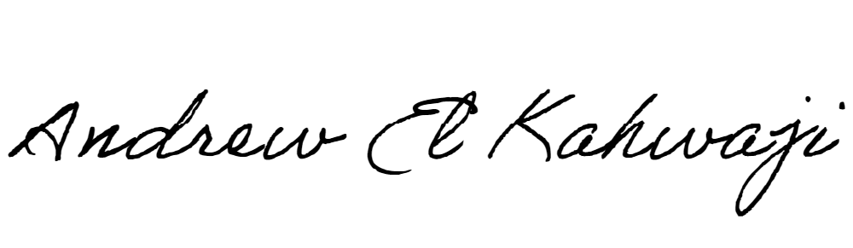

Printed Name _Andrew El Kahwaji_

Date __26/12/2024___

Email __andrew.lifesculptor.coo@gmail.com __

Phone __+961 71 914 378__